Summer Choc-O 2020
Willdale, near Bampton
Dates: Available from 15th June. Last day is 13th September (but check the BL website)
Parking: Roadside parking around NY 4951 1822, west of the cattle grid. It’s about 2km west of Bampton village. Nearest postcode CA10 2QL.
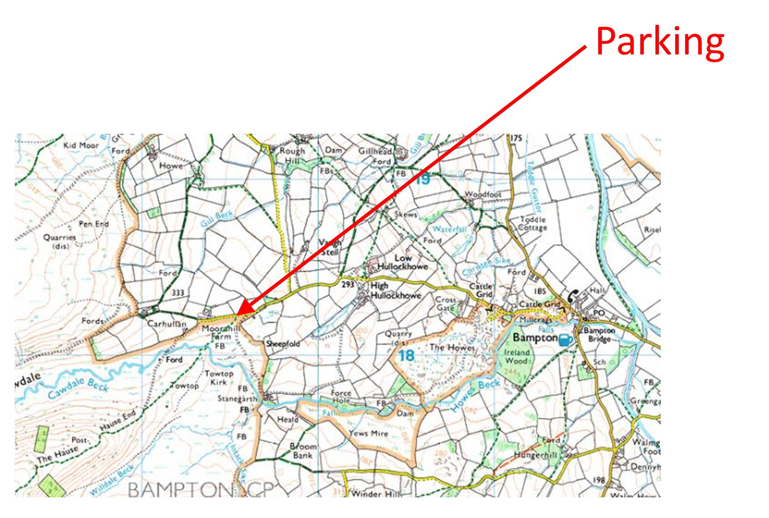

Course lengths: There is a choice of three courses (straight line distances)
- Long: 11.9km, 700m climb
- Medium: 8.0km, 350m climb
- Short: 5.4km, 290m climb
The medium and long courses have no common controls, except the last one. Nor do the short and medium. So, if you want to do more than one course, you will not be too bored!
Map: OS 1:25000 map (Lakes NE OL5). The bounding grid lines are:
- Long: 45-50 (W to E), 13-19 (S to N)
- Medium and Short: 45-50 (W to E), 15-19 (S to N)
Grid Refs: Are 8-digit (i.e. accurate to 10m). However, you should be able to identify the feature on the map using only the 6-digit equivalent.
Start: Grid Ref is 4914 1770 – Ruin SW Side
Control Points: Are wooden stakes about 0.5m high with an orange top. At some of them the courses split. Make sure to read the correct grid reference for your chosen course.
Finish: Because of the COVID situation there is no cache or notebook at the finish. Instead there is a code word written on the post. Email this to us (danandkaren@btinternet.com), plus any comments, and we’ll give you your reward when such things are easier. You’ll need to take your own chocolate if you can’t cope without! On your way back to the parking you will need to cross a river. It’s normally very easy to cross, but if you want a bridge there is one at 4936 1805 and another at 4962 1782.
Bracken: The courses were planned before lockdown when bracken was non-existent. There is not too much even now and it is almost entirely avoidable except around the finish post. Sorry about that.
Safety: The long course reaches a height of around 650m, the medium and short around 550m. They are on an area where you will encounter very few other people and have limited phone reception. Make sure you are suitably equipped. You are entirely responsible for your own safety and not covered by BOF or BL insurance
Problems: If you can’t find a post, or can’t read what is written on it please let us know (danandkaren@btinternet.com).
Instructions for First Timers:
- Decide which course to do (Long, Medium or Short)
- Go to the start point (grid reference above). Here you will find a post with a grid reference and description for the first control
- Locate it on your map and go there. It can be a good idea to write down the grid reference in case you can’t find the control and want to check the grid reference again.
- You will find another post with a grid reference for the next control. There may be different grid references for each course. Make sure to read the correct one.
- Continue like this until you reach the Finish. Here you will find a post with a code word (see “Finish” above).

