Summer Choc-O 2020
Willdale, near Bampton
Dates: Available from 15th June. Last day is 13th September (but check the BL website)
Parking: Roadside parking around NY 4951 1822, west of the cattle grid. It’s about 2km west of Bampton village. Nearest postcode CA10 2QL.
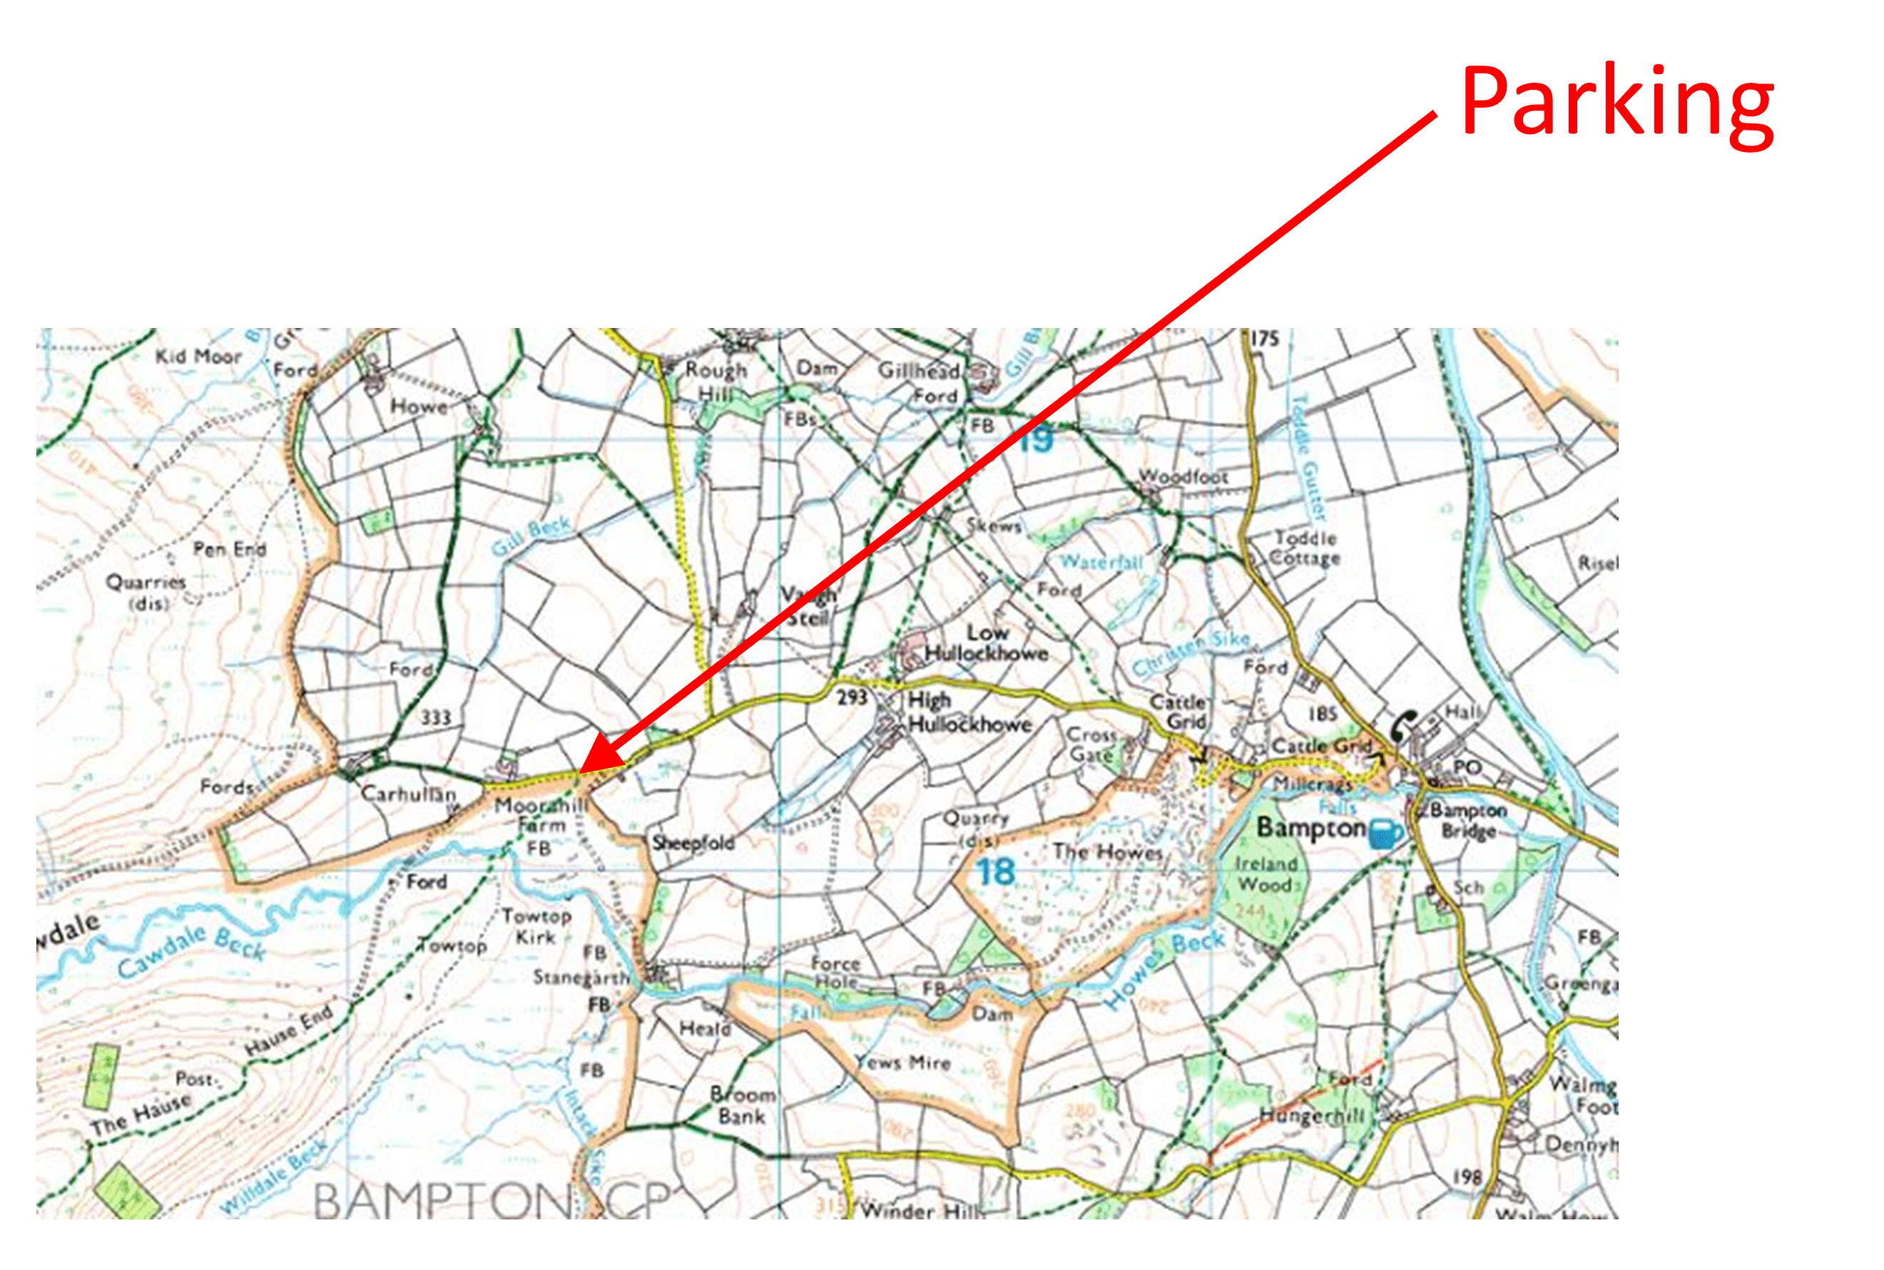

Course lengths: There is a choice of three courses (straight line distances)
- Long: 11.9km, 700m climb, 11 controls
- Medium: 8.0km, 350m climb, 10 controls
- Short: 5.4km, 290m climb, 10 controls
The medium and long courses have no common controls, except the last one. Nor do the short and medium. So, if you want to do more than one course, you will not be too bored!
Map: OS 1:25000 map (Lakes NE OL5). The bounding grid lines are:
- Long: 45-50 (W to E), 13-19 (S to N)
- Medium and Short: 45-50 (W to E), 15-19 (S to N)
Grid Refs: Are 8-digit (i.e. accurate to 10m). However, you should be able to identify the feature on the map using only the 6-digit equivalent.
Start: Grid Ref is 4914 1770 – Ruin SW Side
Control Points: Are wooden stakes about 0.5m high with an orange top. At some of them the courses split. Make sure to read the correct grid reference for your chosen course. The grid references are written on both sides of the post, so if one side has faded or rubbed off, try the other side.
Finish: Because of the COVID situation there is no cache or notebook at the finish. Instead there is a code word written on the post. Email this to us (danandkaren@btinternet.com), plus any comments, and we’ll give you your reward when such things are easier. You’ll need to take your own chocolate if you can’t cope without!
Bracken: The courses were planned before lockdown when bracken was non-existent. There is a bit more now, but nothing too deep and it’s mostly avoidable.
Safety: The long course reaches a height of around 650m, the medium and short around 550m. They are on an area where you will encounter very few other people and have limited phone reception. Make sure you are suitably equipped. You are entirely responsible for your own safety and not covered by BOF or BL insurance
Problems: If you can’t find a post, or can’t read what is written on it please let us know danandkaren@btinternet.com).
Tea Shop: The village shop in Bampton sells ice creams and has a tea room that is probably open. It closes at 4:30pm on Mon, Tue, Thur, Fri and Sun, 12:00 on Wed and 5:00 on Sat.
Instructions for First Timers:
- Decide which course to do (Long, Medium or Short)
- Go to the start point (grid reference above). Here you will find a post with a grid reference and description for the first control
- Locate it on your map and go there. It can be a good idea to write down the grid reference in case you can’t find the control and want to check the grid reference again.
- You will find another post with a grid reference for the next control. There may be different grid references for each course. Make sure to read the correct one.
- Continue like this until you reach the Finish. Here you will find a post with a code word (see “Finish” above).

